**Introduction**

You should now understand how to use DAX formulas and functions in Power BI to create calculated tables and columns.

In this exercise, you’ll apply your knowledge of DAX to add a calculated table and column to an existing dataset.

By completing this exercise, you'll demonstrate your ability to:

* Create a calculated table from the existing dataset within your data model.
* Add calculated columns to a specific table within the dataset.
* Ensure data standardization and consistency.

**Scenario**

Adventure Works needs your help to analyze its sales data to generate insights into its sales performance. However, you must analyze the company’s data without altering the original dataset. You must also create summary tables and normalize dimension tables for analysis.

The company provides you with an Excel workbook called *AdventureWorksData.xlsx*. You must download this file and load it to Power BI to complete your assigned task. Be sure to evaluate the data quality and configure the model to ensure that Adventure Works can use it to make informed decisions.

[AdventureWorksData](https://d3c33hcgiwev3.cloudfront.net/zQrFZ7QpS9Giidk4P2VA3w_174dff423c8b442faa624796461bf4e1_AdventureWorksData.xlsx?Expires=1709942400&Signature=BKHweFPDrjkH9Czwk5LfcX9ljgm2JulOSMT3y-zgkSOTrTcr3HUtwicBxZu7U2ck28jucqg9KM~Gje~GqyN1fxIF-nwGEmW1cxxYYYfCU3fYlXj~oOUKVphJZ1zX3DO3~LH5b~DedbVB0pFuIKQbx2uxmeeHTQqk~igqi0VaYy8_&Key-Pair-Id=APKAJLTNE6QMUY6HBC5A" \t "_blank)

[XLSX File](https://d3c33hcgiwev3.cloudfront.net/zQrFZ7QpS9Giidk4P2VA3w_174dff423c8b442faa624796461bf4e1_AdventureWorksData.xlsx?Expires=1709942400&Signature=BKHweFPDrjkH9Czwk5LfcX9ljgm2JulOSMT3y-zgkSOTrTcr3HUtwicBxZu7U2ck28jucqg9KM~Gje~GqyN1fxIF-nwGEmW1cxxYYYfCU3fYlXj~oOUKVphJZ1zX3DO3~LH5b~DedbVB0pFuIKQbx2uxmeeHTQqk~igqi0VaYy8_&Key-Pair-Id=APKAJLTNE6QMUY6HBC5A" \t "_blank)

**Instructions**

Create a new Power BI project called *Exercise – Adding a calculated column and table*. Follow the steps below to complete the exercise.

**Step 1: Download and connect to the Adventure Works Dataset.**

1. Download and save the Excel workbook **AdventureWorksData.xlsx**. The workbook contains five data tables: **Sales**, **Date**, **Products**, **Region**, and **Salesperson**.

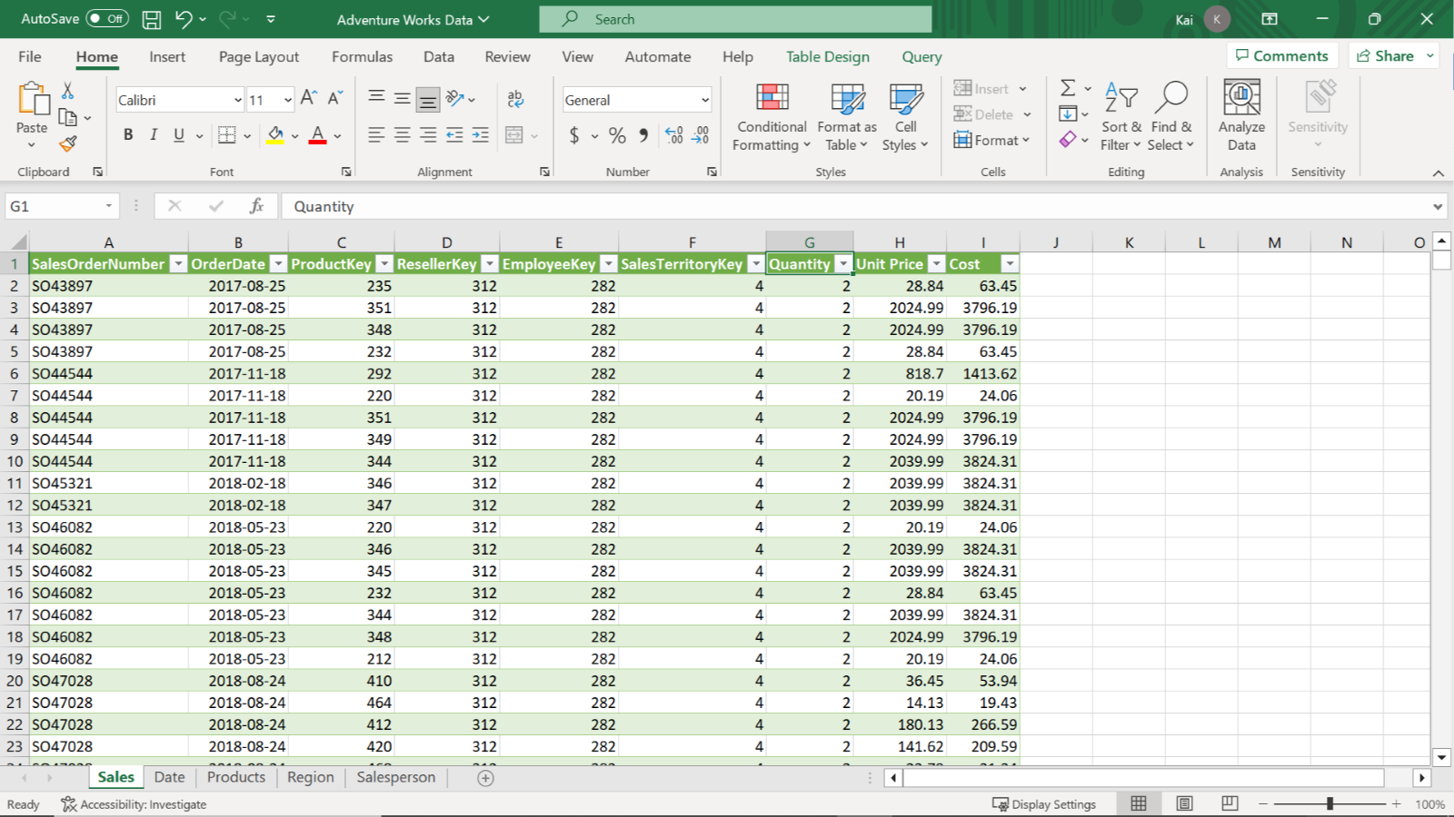

1. Load the data from the Excel sheet into Power BI. Ensure you load all tables in the workbook.
2. Open a preview of the table in the **Preview** pane.

* **Tip:** You can import data using the **Get Data** drop-down menu.

**Step 2: Remove all duplicate values and set the relationships between the tables.**

1. Remove all duplicate values from the **SalesOrderNumber** column of the **Sales** fact table.
2. Ensure that one-to-many relationships exist between the fact table and all dimension tables. Once you load the data, Power BI will establish the table relationships automatically. If any relationship is missing, create it manually.

* **Tip:** You can view and configure model relationships in **Model view** of Power BI desktop. You can create and edit relationships in **Manage Relationship** view of Power BI desktop.

**Step 3: Create a calculated table.**

1. Create a new calculated table called **Yearly Sales by Color** that contains the following data:

* All data from the **Sales** table,
* All **Product Color**data from the **Product** table,
* And all Yearly values from the **Date** table.

1. Note down the total number of columns in the table.

* **Tip:** Create the calculated table using the **ADDCOLUMNS** and **RELATED** DAX functions.

**Step 4: Create calculated columns.**

1. Create a calculated column in the **Date** table called **Qtr** and populate it with data for each quarter of the year.
2. Create a second calculated column in the **Date** table called **Month** and populate it with the name of each month(Display each month’s name as just the first three letters of each month’s name).
3. Create a calculated column in the **Sales** table for **Product Color**.

* **Tip:** You can create columns using the **New column** feature from the table tools tab of Power BI’s desktop interface, along with the **RELATED**, **MONTH**, and **QUARTER** DAX functions. You can use the **MONTH DAX** function to display each month’s name.

**Step 5: Save your Power BI project.**

* Save your Power BI project to your local computer.
* **Tip:** Make sure you select an appropriate project name and folder path.

**Conclusion**

By completing these steps, you’ve successfully created a calculated table by combining data from multiple datasets and user-defined columns using DAX. You can now analyze Adventure Works data based on the analytical and business requirements.

When using DAX formulas, always ensure they are correctly formatted and that the column names match the actual column names in your data.

1. [Week 2](https://www.coursera.org/learn/data-modeling-in-power-bi/home/week/2)
2. Exemplar: Adding a calculated table and column

[Previous](https://www.coursera.org/learn/data-modeling-in-power-bi/quiz/2pEhg/self-review-adding-a-calculated-table-and-column)[Next](https://www.coursera.org/learn/data-modeling-in-power-bi/quiz/RasOt/knowledge-check-using-data-analysis-expressions-dax-in-power-bi)

**Exemplar: Adding a calculated table and column**

**Overview**

In the exercise *Adding a calculated table and column*, you were asked to create new calculated tables and columns using DAX within your data model to address specific analytical and visualization concerns.

Your tasks in this exercise were to:

* Create a calculated table from the existing dataset within your data model.
* Add calculated columns to a specific table within the dataset.
* Ensure data standardization and consistency.

This reading provides you with a step-by-step guide for completing these tasks. It also includes screenshots that you can compare against your work.

You can also review the [*Introduction to calculated tables*](https://www.coursera.org/learn/data-modeling-in-power-bi/lecture/OLf8s/introduction-to-calculated-tables) and [*Creating calculated columns*](https://www.coursera.org/learn/data-modeling-in-power-bi/lecture/Jkzfj/creating-calculated-columns) videos for guidance on using DAX in Power BI.

**Step 1: Download and connect to the Adventure Works Dataset.**

1. Download the workbook from the exercise page on the Coursera platform.



1. Launch Power BI desktop. To create a new project, select the **File** menu, then select **New**. Import the Adventure Works dataset that you have downloaded. In the **Home** tab, select the **Get Data** drop-down menu. Then select an appropriate data source. For the current exercise, select **Excel Workbook** and navigate to the Adventure Works dataset folder.

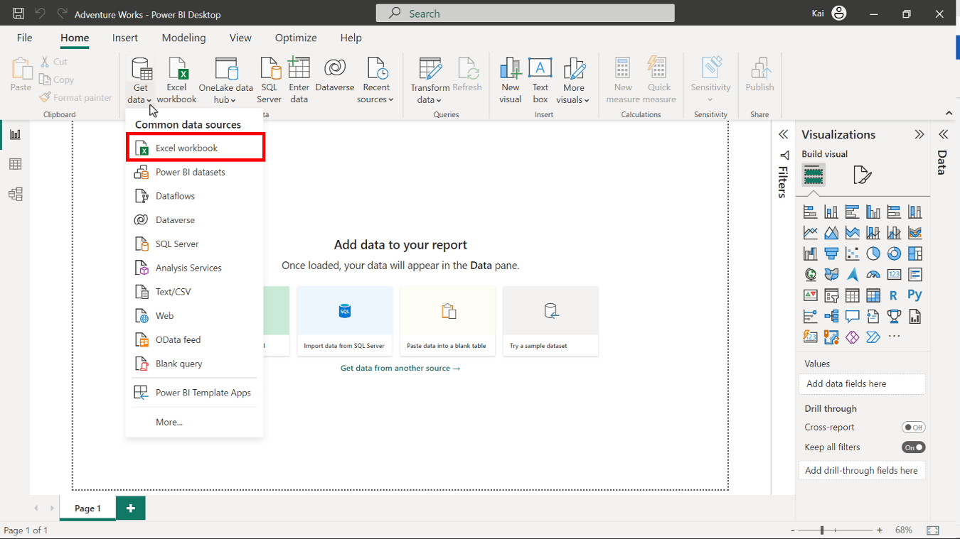

3. Once you select and load the data, Power BI opens a **Navigator** dialog box that lists all the tables available to load in the Excel file, along with the data preview on the right side of the Navigator. Select the **Sales**, **Product**, **Region**, **Date,** and **Salesperson** tables, then select **Load**.

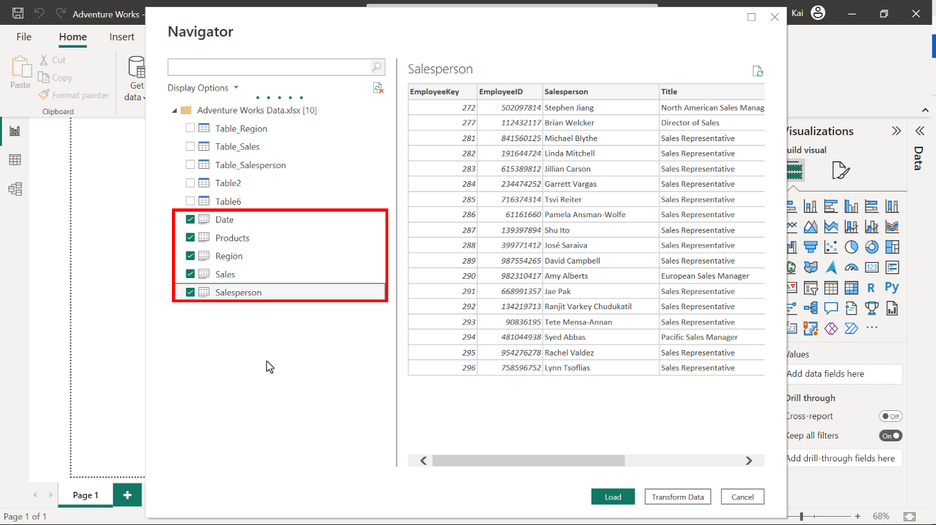

**Step 2: Remove all duplicate values and set the relationships between the tables.**

1. To eliminate all duplicate data, access the **Power Query editor**, right-click on the **SalesOrderNumber** columns, and select **Remove duplicates** from the drop-down menu.

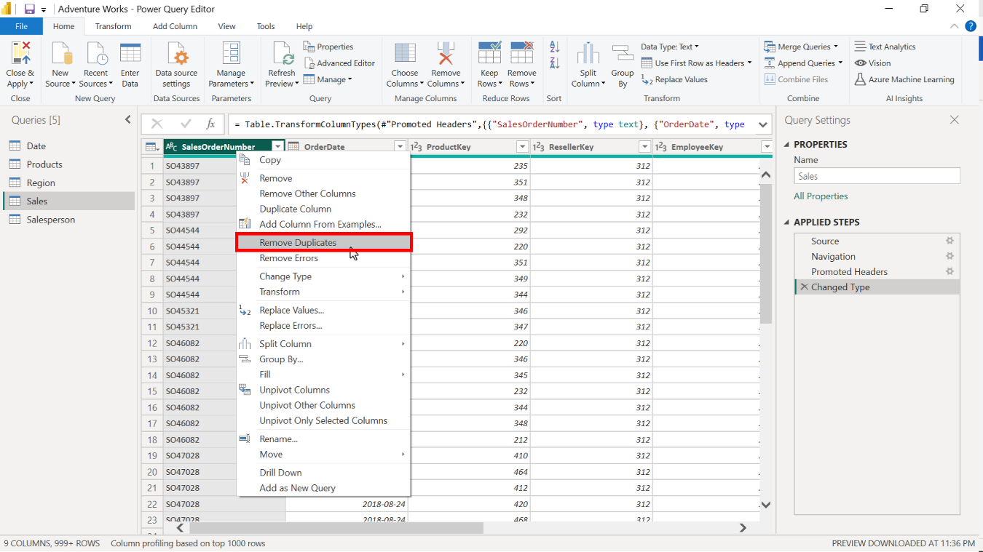

1. To configure the model relationships, access the **Model view** of Power BI desktop and select **Manage relationships**. From here, you can edit cardinality and cross-filter direction between the tables.

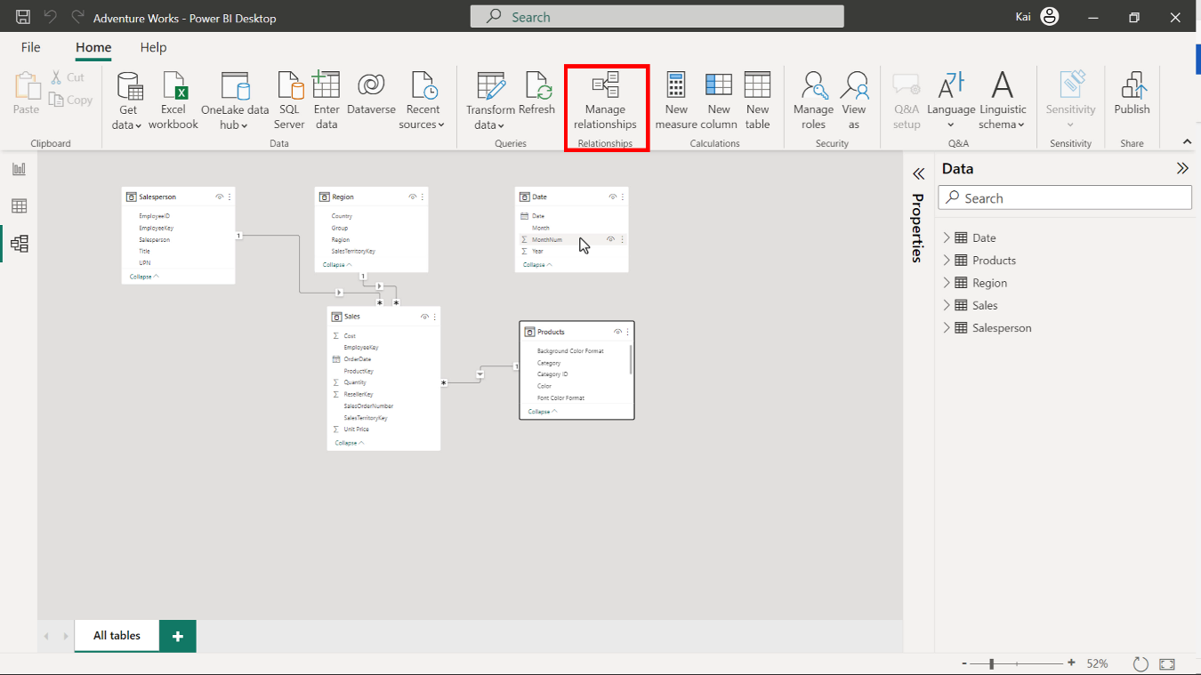

**Step 3: Create a calculated table.**

1. Access the **Model view** in the calculations group to create a new table. Select **New table**. Copy and paste the following DAX code into the formula bar:

1

2

3

4

5

Yearly Sales by color =

ADDCOLUMNS (

Sales,

"Year", RELATED ( 'Date'[Year]),

"Color", RELATED ( Products[Color]))

* **ADDCOLUMNS**: Adds calculated columns to the given table or table expression. In this instance, the **Sales** table is the main table to which you need to add two more columns, one from the **Date** table and one from the **Product** table.
* **Year** and **Color** in double quotes are the names of the new columns to be added in the new calculated table.
* **RELATED**: Returns a related value from another table. In this case, **Product color values** from the **Product table** and **Year** information from the **Date** table.

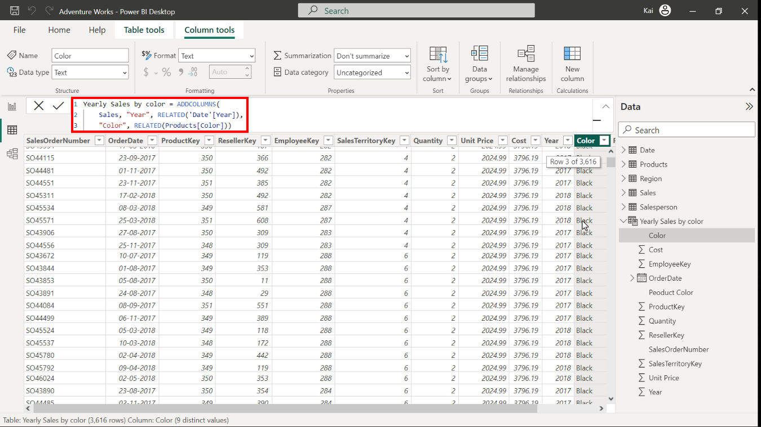

1. Note that the resulting table has 11 columns.

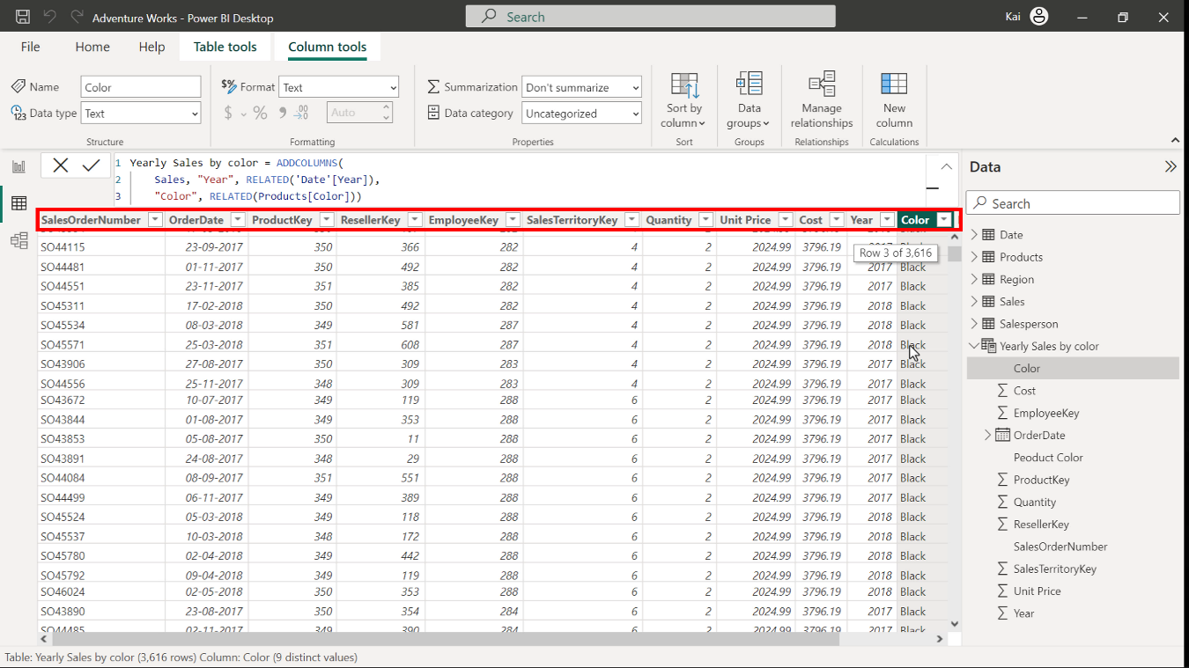

**Step 4: Create calculated columns.**

1. To create a new column, select the **Date** table from the **Data pane** on the right side of Power BI interface. Access **Model view** in the **Calculations group** and select **New column**. Copy and paste the following DAX code into the formula bar:

1

Qtr = QUARTER('Date'[Date])

* **QUARTER**: Returns each quarter as a number from the **Date** column.
* **Date** in single quotes is the table, and **Date** in square brackets is the column within the table.

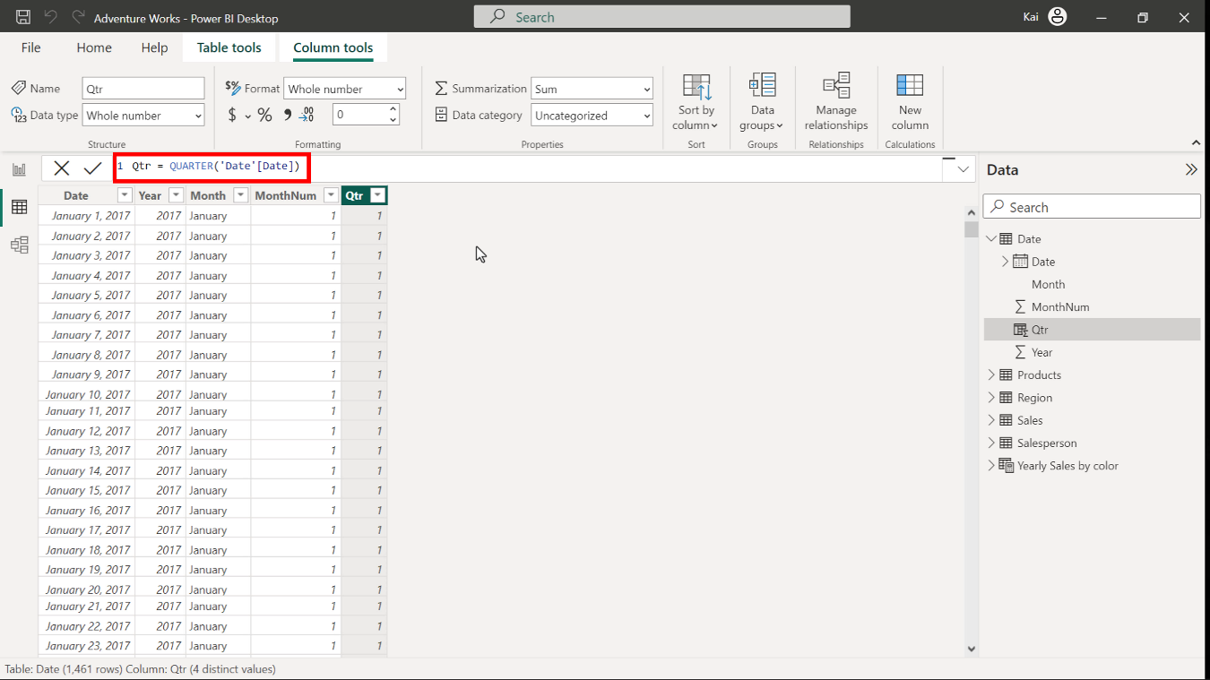

1. Select the **Date** table from the **Data pane** on the right side of Power BI interface. Access **Model view** in the **Calculations group** and select **New column**. Copy and paste the following DAX code into the formula bar:

1

Month =LEFT ( 'Date'[Month], 3 )

* **LEFT**: Returns the specified number of characters from the start of a text string.
* **Date** in single quotes is the table to be referenced, and **Month** in square brackets is the column name. The number **3** specifies the number of characters in the short month column.

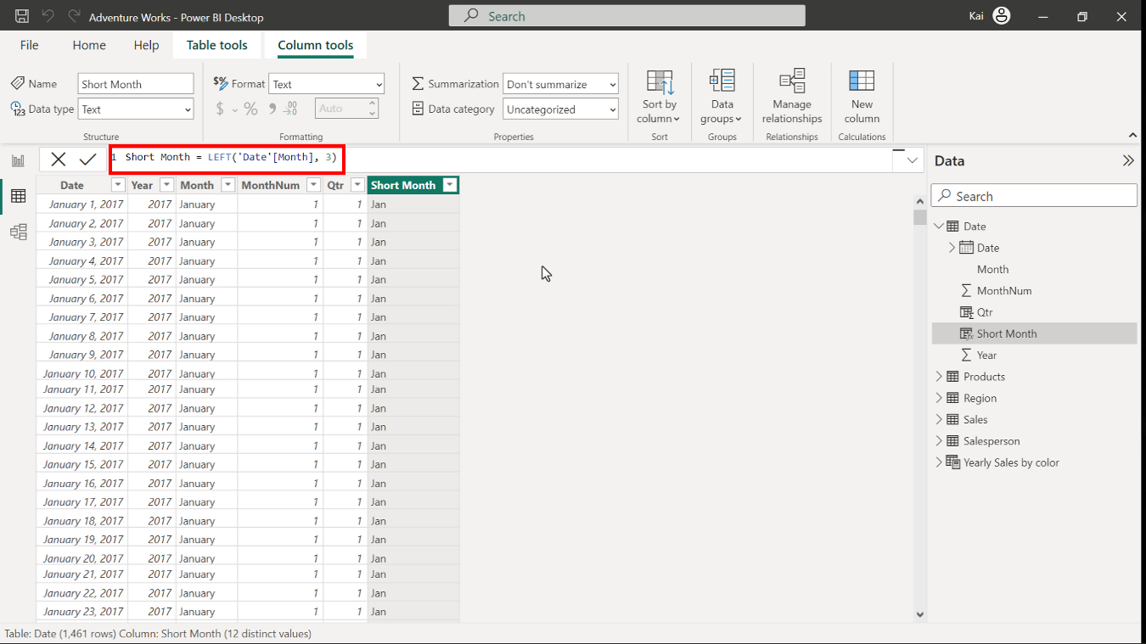

1. To create a new column, select the **Product** table from the **Data pane** on the right side of Power BI interface. Access **Model view** in the **calculations group**. Thenselect **New column** to expand the formula bar. Copy and paste the following DAX code into the formula bar:

1

Product Color = RELATED ( Products[Color] )

* **RELATED** here is the same as referencing a column from another table.

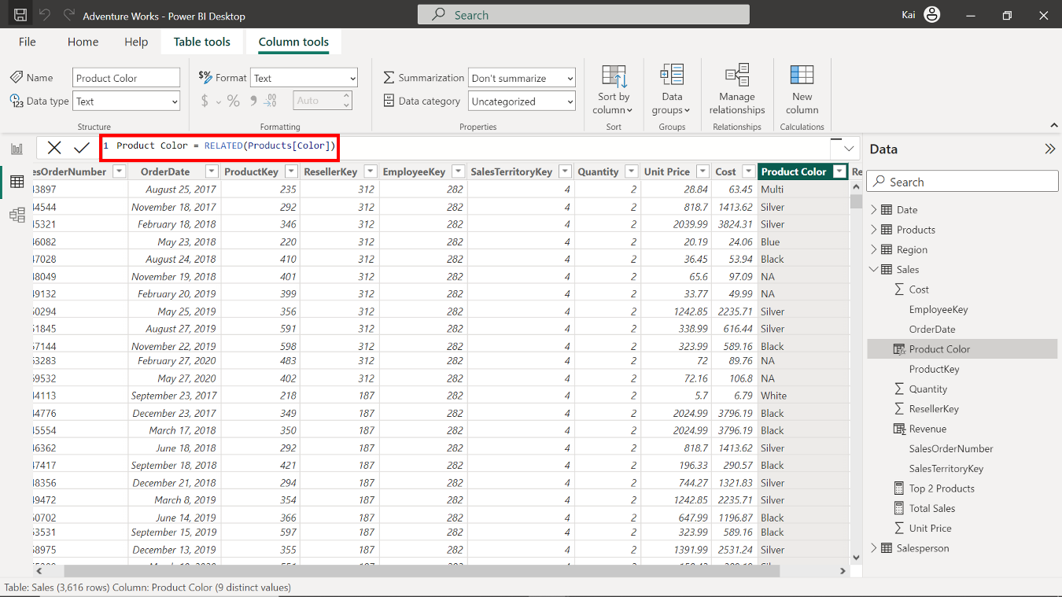

**Step 5: Save your Power BI project.**

* To save the project, open the **File** menu, select **Save As,** and provide an appropriate name for the project along with a path to the folder on your computer.

**Conclusion**

With these steps, you have successfully created a calculated table by combining data from multiple datasets and user-defined columns using DAX. You can now analyze Adventure Works data based on the analytical and business requirements.

Remember that when using DAX formulas, always ensure they are correctly formatted and that the column names match the actual column names in your data.